Jenkins architecture:

* Jenkins follows Master-Slave architecture to manage distributed builds.
* In this architecture, slave and master communicate through TCP/IP protocol.
* Jenkins architecture has two components:
* Jenkins Master/Server
* Jenkins Slave/Node/Build Server

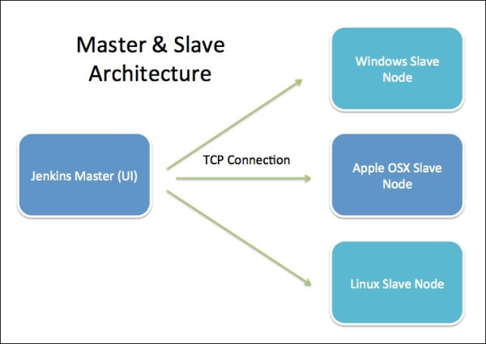

Jenkins Master

* The main server of Jenkins is the Jenkins Master.
* It is a web dashboard which powered from a war file.
* By default it runs on 8080 port.
* With the help of Dashboard, we can configure the jobs/projects but the build takes place in Nodes/Slave. By default one slave is configured and running in Jenkins server. We can add more nodes using IP address, user name and password using the ssh or some methods.
* The master's job is to handle:

1. Scheduling build jobs.
2. Dispatching builds to the slaves for the actual execution.
3. Monitor slaves.
4. Recording and presenting the build results.
5. A Master/Server instance of Jenkins can also execute build jobs directly.

Paint shop

Engine shop

Body Shop